During “Earth and Recycling” week, students learned how Earth is important for human life and how to treasure our unique Earth. Tr. Jackie helped students realize that we need to cherish Earth by reusing materials and reducing pollution.
Let’s produce a recycled paper!!
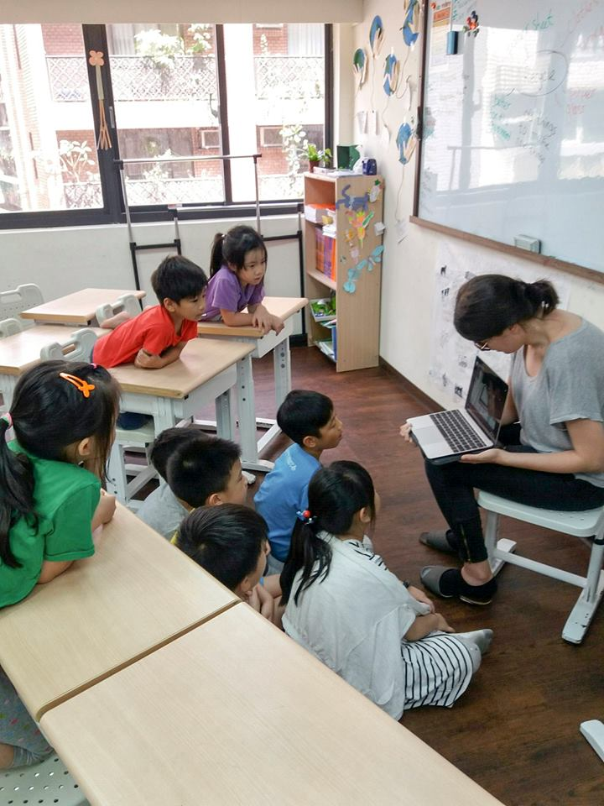
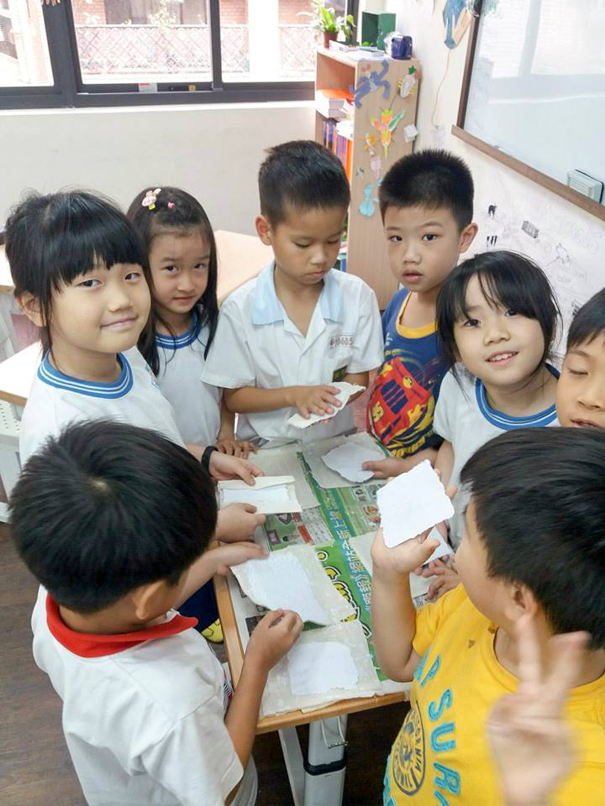
During “Farm Animals” week, students thought about how animals supply different products to meet the needs of the people’s everyday life.
Butter is a common food that people eat, but do we know how it is made?
Let Tr. Jackie tell you how to make yummy butter~
